23.62: Recall from Example 23.12 for a line of charge of length :
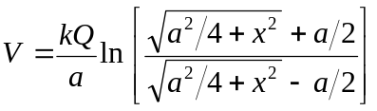
a) For a square with two sets of oppositely charged sides, the potentials cancel and 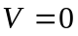.
b) If all sides have the same charge we have:
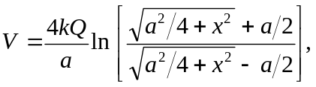 but here 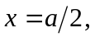 so:

